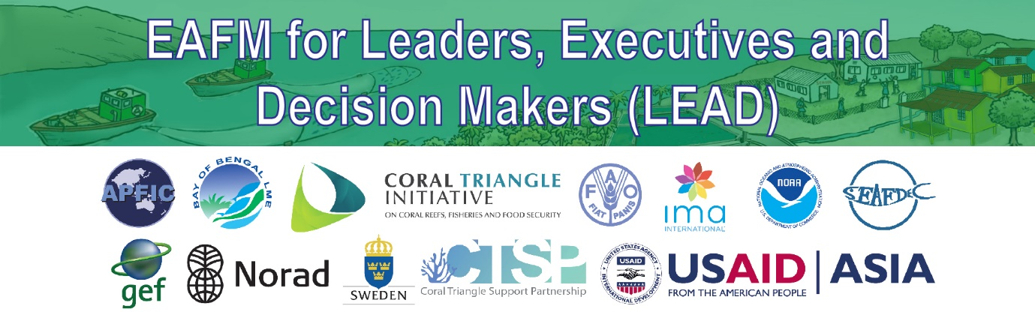
D1: Qualifications
Profile for a LEAD facilitator
- Committed and passionate about EAFM = champion
- More Senior person
- Trusted and respected by leaders
- Impartial
- Knowledge of fishery/environment/NR/country investment plan/country strategy context
- Fluent in national language
- People skills
- Very skilled at thinking on the spot
- Local knowledge
- Ability to weave leaders’ issues into main messages/ validate
- Need to be conversant with LEAD suite of products and EEAFM package (exposure to videos and materials)

